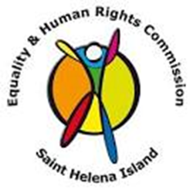
EQUALITY AND HUMAN RIGHTS.
  - The 24th of January is the International Day of Education and that is a United Nations annual international observance day.
What is the International Day of Education?
The International Day of Education is annually celebrated on January 24. This year’s theme is ‘changing course, transforming education’.
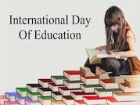
Why the International Day of Education is important?
With the cable coming to St Helena by the end of the year, it will generate debate around how to strengthen education as a public endeavour and common good, how to steer the digital transformation, support teachers and even help them to make their lessons more fun for children. By making it more fun, the children will take in more as it’s not just sitting and listening, they are now interacting. We will be able to safeguard the planet by learning how to keep the environment clean and safe, learn more about climate change and unlock the potential in every person to contribute to our collective wellbeing and our shared home.
Why is it important to have education?
Education provides stability in life, and its something that no one can ever take away from you. By being well – educated maybe holding a college degree, you increase your chances for better career opportunities. You can do online courses so you actually have a certificate going to the job with you. There will be a better range of GCSE’s available at school and the St Helena Community College that could add up to some experiences before you start the job. It would be a lot easier with faster internet watching videos that demonstrates the course a lot better than just reading for hours and not taking anything in, it will open up new doors for yourself. You have a right to Education
Contact no – human rights – 22133
‘Education is the most powerful weapon which you can use to change the world’ – Nelson Mandela

